TUẦN 2 TỪ NGÀY 13/9-18/9/2021
UNIT 1: HOME
Lesson 2: Vocabulary & Listen ( page 9 – Student’s book)
I.VOCABULARY (TỪ VỰNG)

No | Words |  | Transcription | Meaning
7 | bed | (n) | /bed/ | Cái giường
8 | clean | (v) | /kliːn/ | Dọn dẹp, rửa
9 | dinner | (n) | /ˈdɪnər/ | Bữa tối
10 | dish | (n) | /dɪʃ/ | Cái đĩa
11 | kitchen | (n) | /ˈkɪtʃən/ | Nhà bếp
12 | laundry | (n) | /ˈlɔːndri/ | Việc giặt là (ủi)
13 | shopping | (n) | /ˈʃɒpɪŋ/ | Việc mua sắm

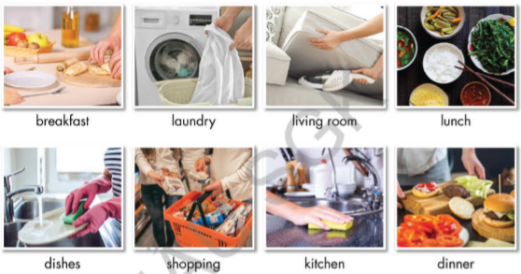

❷ Practice:
UNIT 1: Home Lesson 2
- bed (n) /bed/: Cái giường -> make the bed: dọn giường
……………………………………………………………………………………….……………………………………………………………………………………….
……………………………………………………………………………………….
- clean (v) /kli:n/: Dọn dẹp, rửa, lau, chùi -> clean the kitchen: lau bếp
……………………………………………………………………………………….……………………………………………………………………………………….
……………………………………………………………………………………….
- dinner (n) /'dinər /: Bữa tối -> make dinner: nấu bữa tối
……………………………………………………………………………………….……………………………………………………………………………………….
……………………………………………………………………………………….
- dish (n) /dɪʃ/: Cái dĩa -> do the dishes: rửa chén dĩa
……………………………………………………………………………………….……………………………………………………………………………………….
……………………………………………………………………………………….
- kitchen (n) /kɪtʃən/: Nhà bếp -> clean the kitchen: lau bếp
……………………………………………………………………………………….……………………………………………………………………………………….
……………………………………………………………………………………….
- laundry (n) /ˈlɔːndri/: Việc giặt là (ủi) -> do the laundry: giặt đồ
……………………………………………………………………………………….……………………………………………………………………………………….
……………………………………………………………………………………….
shopping (n) /ˈʃɒpɪŋ/: Việc mua sắm -> do the shopping/ go shopping
……………………………………………………………………………………….……………………………………………………………………………………….
……………
II. Read the sentences and underline the correct answers (Workbook, Unit 1. Page 4)
1. My sister often makes breakfast/ dinner in the morning.
2. The plates are dirty. I need to do the shopping/ dishes.
3. Jenny makes breakfast/ does the dishes after eating lunch.
4. Let’s clean the bathroom/ eat breakfast. It’s so dirty.
5. My mom do the shopping/ laundry. My clothes are always really soft.
6. We’re out of juice. Can you buy some when you do the laundry/ shopping?

❸ GRAMMAR:

I. Underline the mistake in each sentence. Write the correct word on the line.
(Student’s book, Review 1. Page 87)
1. What are Manchester famous for? __________
2. My house have a balcony and a garage. __________
3. I do lots of housework! I cleaning the bedroom on the weekend. __________
4. Do your family have a car? __________
5. What housework does you do? __________
6. My sister and I don't making the dinner. __________
7. There is two seasons: the dry season and the rainy season. __________
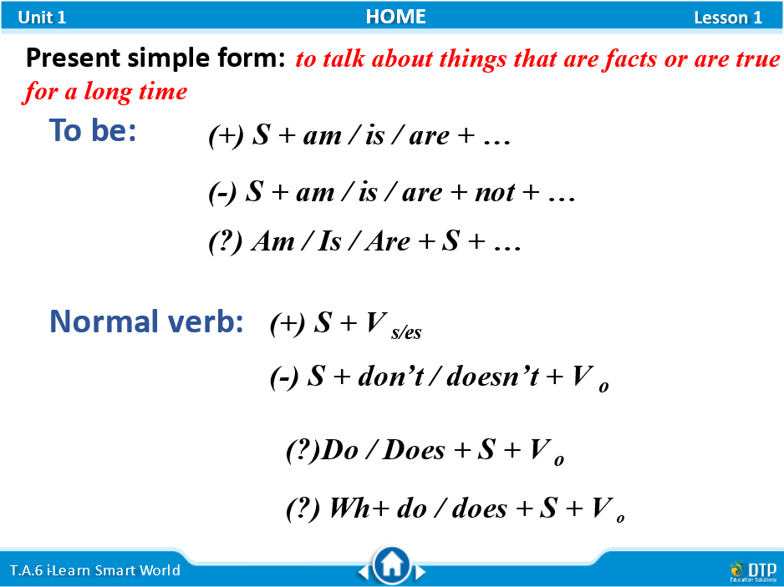

III. Underline the correct answers
1. We sometimes (read/ reads) books.
2. Emily (go/ goes) to the art club.
3. It often (rain/rains) on Sundays.
4. Pete and his sister (wash/washes) the family car.
5. I always (hurry/ hurries) to the bus stop.
6. She (speak/ speaks) four languages.
7. Jane is a teacher. She (teach/ teaches) French.
8. Those shoes (cost/ costs) too much.
9. My sister (go/ goes) to the library once a week.
10. We both (listen/ listens) to the radio in the morning.

III. the affirmative form (+). Change the verb into the correct form
- I usually ______________ (go) to school.
- He ______________ (brush) his teeth after meals.
- They ______________ (visit) us often.
- She often ______________ (wash) her clothes at night.
- You ______________ (play) basketball once a week.

---The end ---

